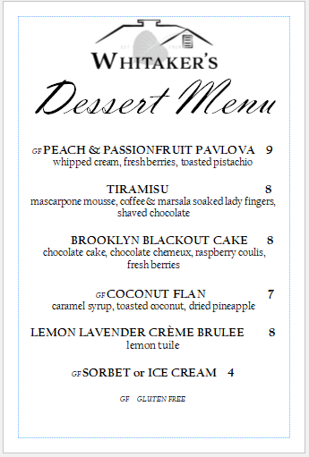

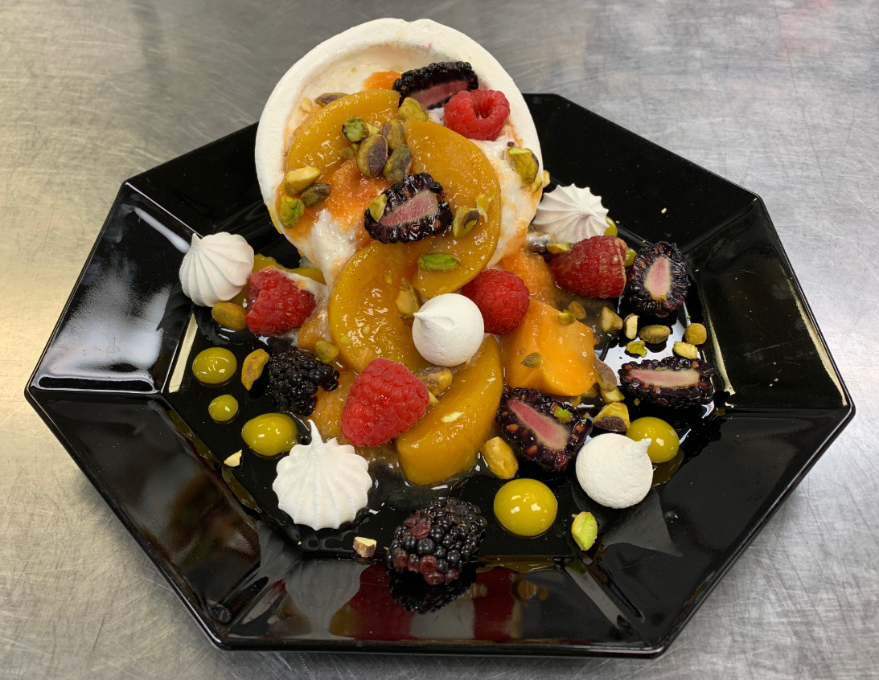
GF PEACH & PASSION FRUIT PAVLOVA $9
Whipped cream, fresh berries, toasted pistachio

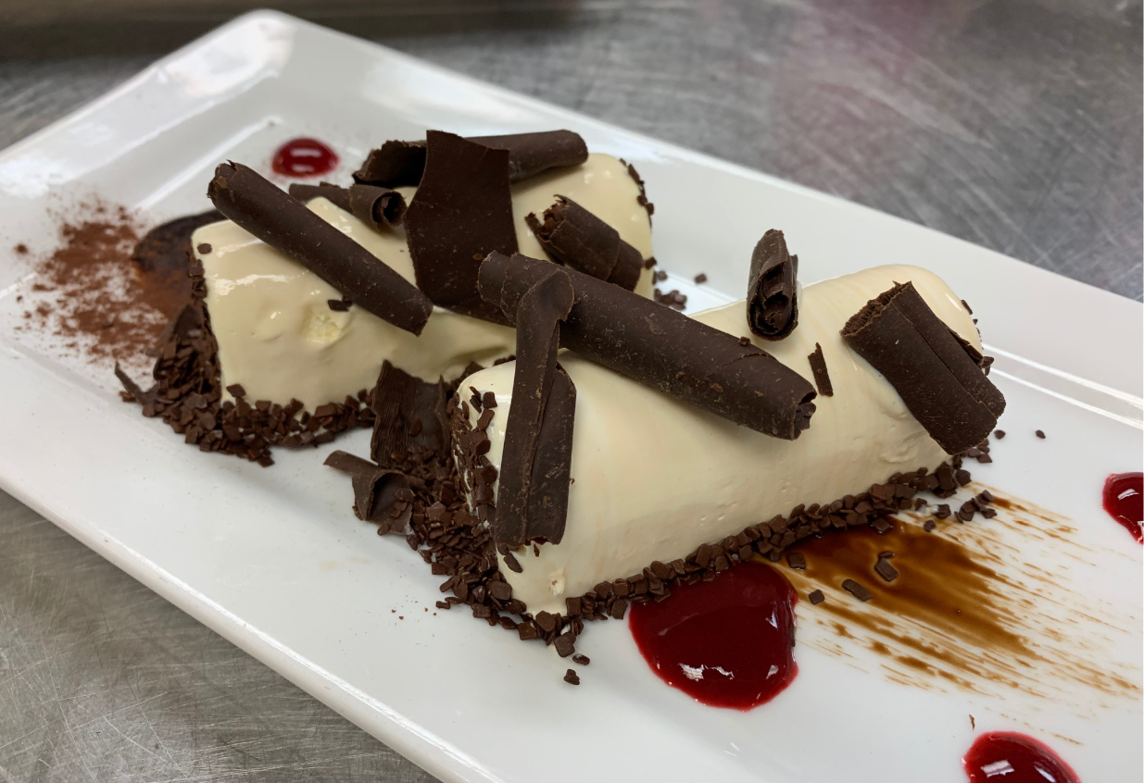
TIRAMISU $8
Mascarpone mousse, coffee & marsala-soaked lady fingers, shaved chocolate
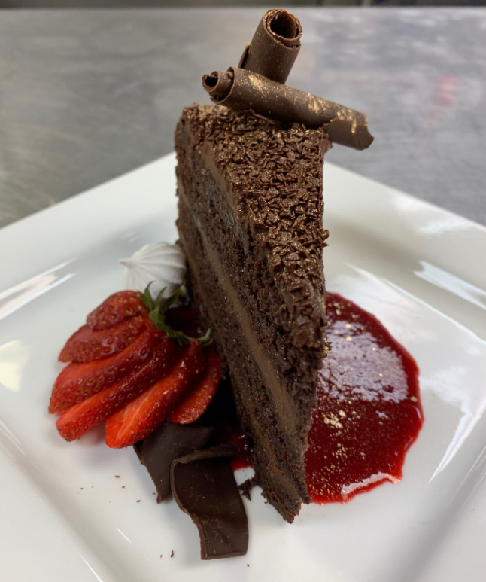
BROOKLYN BLACKOUT CAKE $8
Chocolate cake, chocolate chemeux, raspberry coulis, fresh berries

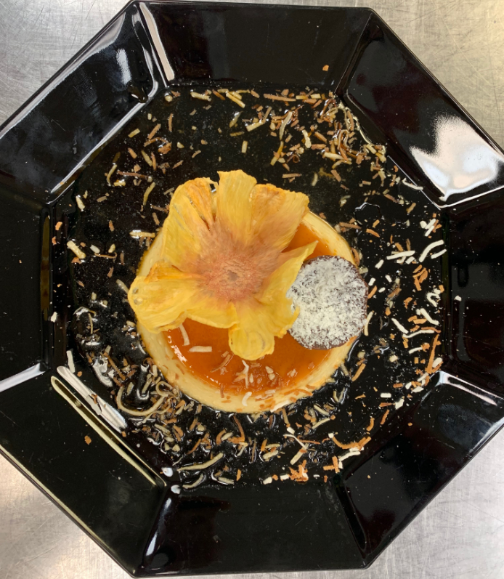
GF COCONUT FLAN $7
Caramel syrup, toasted coconut, dried pineapple

